**FINAL Lab Quiz 2:**

**Registration with Event**

**Requirements:**

* **Java Code**
* **NetBeans IDE**
* **Documentation**

**Groupmates:**

(List here the names of your group and their contribution)

**Note: This is an individual activity**

**Lab Activity Problem:**

1. Create a program that register data, it gets the inputted data of user and post it in frame.

Name: (TextField)

Mobile: (TextField)

Gender: (Radio Button)

Date of Birth: (JTextField or JComboBox)

Address: (TextArea)

Button: Submit and Reset (JButtons)

Grade Matrix:

Functionality(Events) : 40%

Design : 30%

Documentation : 30%

100%

*BTSRegistration.java*

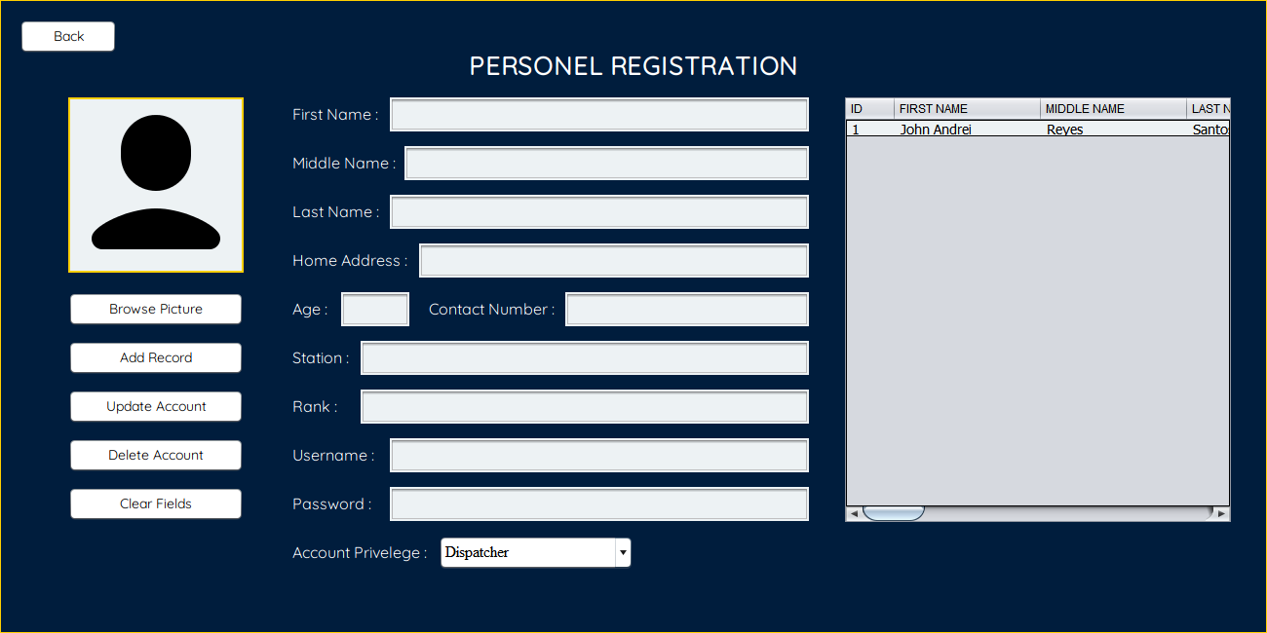

This JFrame window that Adds, Updates, and Registers users data in the Police Record Management System. This creates an account for the user to be able to log into the Login Window.

This JFrame Class includes, 1 JPanel (as Background), 6 JButtons, 13 JLabels, 10 JTextFields, and a JTable.

**PRMS Register Source Code Summary**

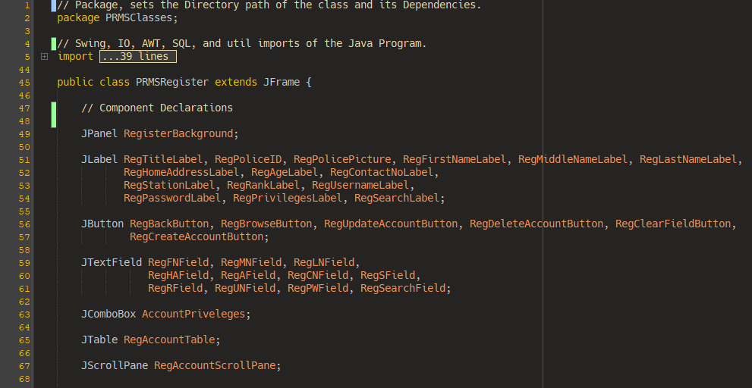

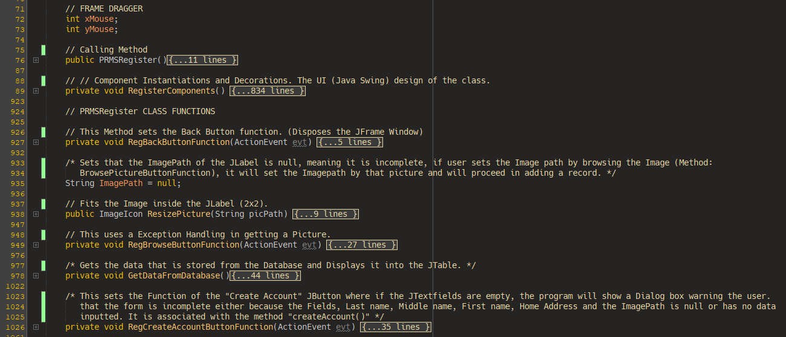

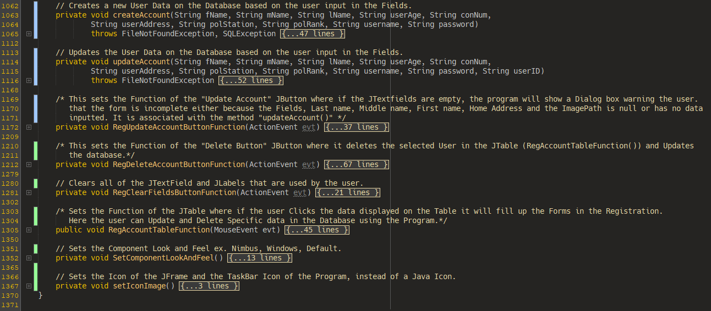

*BTSSplash.java*

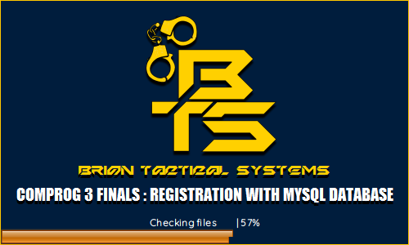

This JFrame window displays the Splash Screen before proceeding into the PRMSLogin Window. This presents the startup of the program.

This JFrame Class includes, 1 JPanel, 4 JLabels, and a JProgressBar.

**PRMS Splash Screen Code Summary**

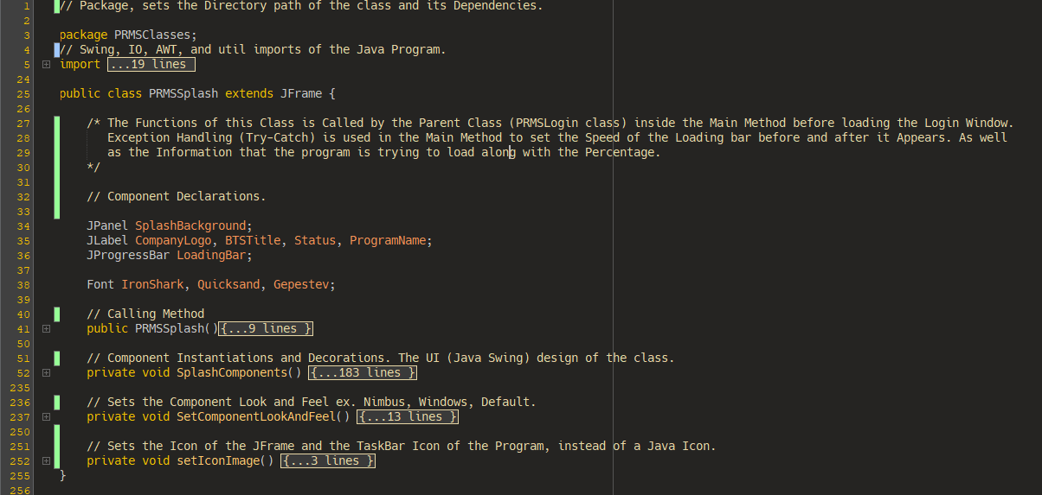

*DBConnection.java*

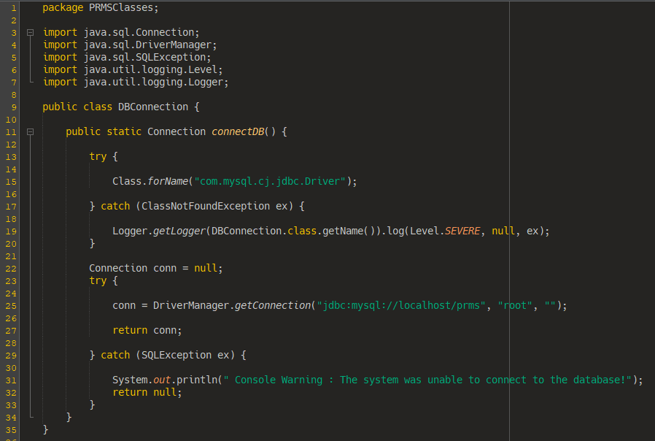

This Java Class establishes the connection between the Program and the Database, in this Case MySQL database is used in this Management System. It first gets the JDBC Driver (Also called ConnectorJ) that is included in the Libraries. Using exception handling, assuming that the connection is null, if the database is not running, the program will warn the user that the database is not running at startup or at the PRMS Login Class. But if the Connection is established, it will proceed in logging into the database using the URL link of the JDBC, Root username and password.

*MySQL Database via WAMP Server.*

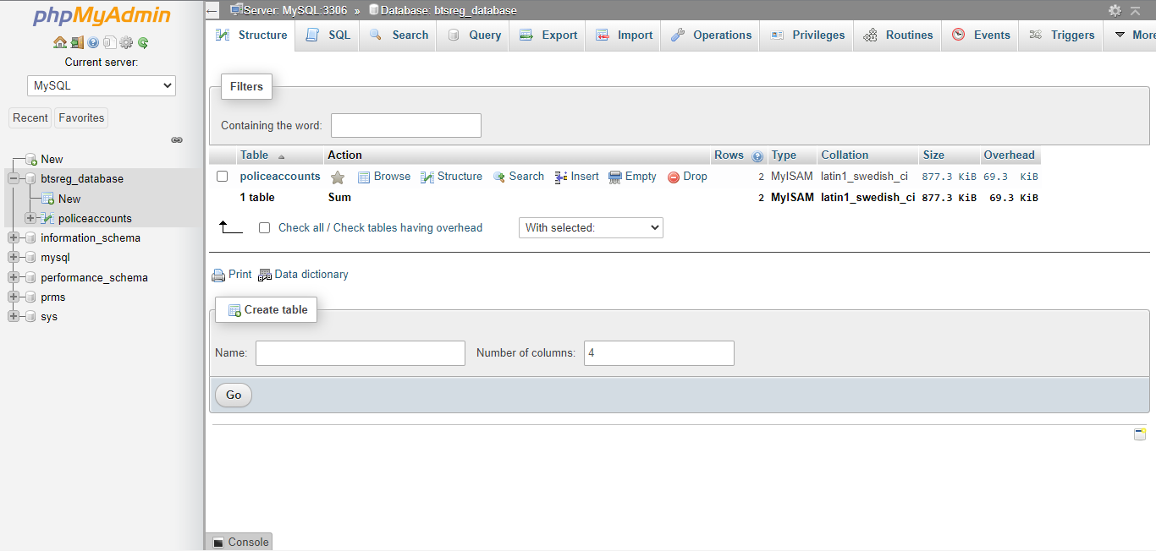

This is MySQL Database via the Browser. This is where all of the User Accounts and Personal Records are stored. Recommended for Beginners. The “btsreg_database.sql” file is in the folder named “Import Database File Before Use” that you can import into SQL.

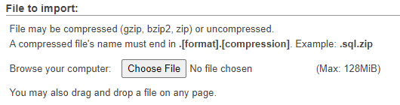

Here are the Instruction from the Database in Importing the prms.sql file.

A Video Demo is Included in making the program work.   
File Name : Project Demo.mkv